1940223_CIA1_test.R

pranav

2020-01-25

#Question 2  
library(lattice)  
data = read.csv("sports.csv", header = TRUE, sep = ';')  
attach(data)  
data

## days team gd gs win loss home points inj cards  
## 1 1 1 2 1 1 0 1 3 0 1  
## 2 2 1 1 0 1 0 1 6 0 3  
## 3 3 1 3 0 1 0 0 9 1 2  
## 4 4 1 0 0 0 0 1 10 1 0  
## 5 5 1 5 1 1 0 0 13 2 2  
## 6 6 1 4 2 1 0 1 16 2 4  
## 7 7 1 0 1 0 1 1 16 3 2  
## 8 8 1 1 1 0 0 0 17 3 3  
## 9 9 1 2 1 1 0 0 20 4 5  
## 10 10 1 3 2 1 0 1 23 4 1  
## 11 11 1 4 0 1 0 0 26 4 0  
## 12 12 1 2 0 1 0 0 29 4 2  
## 13 13 1 2 1 1 0 1 32 4 2  
## 14 14 1 0 1 0 1 1 32 5 3  
## 15 15 1 1 2 0 1 0 32 5 1  
## 16 16 1 1 0 1 0 1 35 5 2  
## 17 17 1 0 0 0 0 1 36 5 6  
## 18 18 1 4 2 1 0 0 39 5 2  
## 19 19 1 3 0 1 0 1 39 6 1  
## 20 20 1 2 0 1 0 1 39 6 5  
## 21 1 2 2 0 1 0 0 3 0 2  
## 22 2 2 1 0 1 0 0 6 0 1  
## 23 3 2 1 2 0 1 1 6 0 0  
## 24 4 2 0 1 0 1 0 6 0 3  
## 25 5 2 0 3 0 1 1 6 1 3  
## 26 6 2 3 2 1 0 0 9 1 5  
## 27 7 2 2 1 1 0 0 12 1 4  
## 28 8 2 2 0 1 0 1 15 2 2  
## 29 9 2 1 2 0 1 1 15 2 5  
## 30 10 2 0 1 0 1 0 15 2 1  
## 31 11 2 1 1 0 0 1 16 3 0  
## 32 12 2 1 3 0 1 1 16 3 2  
## 33 13 2 0 0 0 0 0 17 3 3  
## 34 14 2 2 0 1 0 0 20 3 4  
## 35 15 2 3 1 1 0 1 23 3 2  
## 36 16 2 2 0 1 0 0 26 3 1  
## 37 17 2 1 2 0 1 0 26 3 0  
## 38 18 2 0 2 0 1 1 26 3 1  
## 39 19 2 0 1 0 1 0 26 4 2  
## 40 20 2 1 0 1 0 1 29 4 2

#Question 3  
table = table(as.factor(team), gd)  
table

## gd  
## 0 1 2 3 4 5  
## 1 4 4 5 3 3 1  
## 2 6 7 5 2 0 0

barplot(main = "Goals per team", table, ylab = "Goals done")

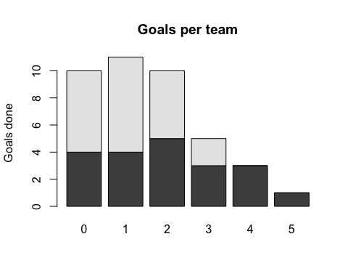

#Question 4  
densityplot(main = "Density plot of goals received per team", ~gs, groups = team, legend = rownames(team))

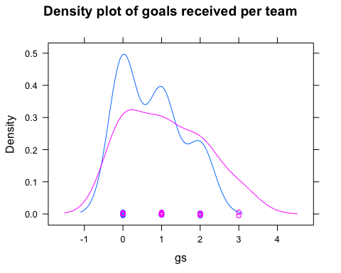

#Question 5  
histogram(main = "Win matches per team", win, groups = team)

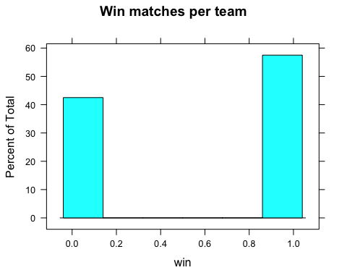

#Question 6  
?cut  
xyplot(main = "Goals received per team", gs~team, cut = TRUE)

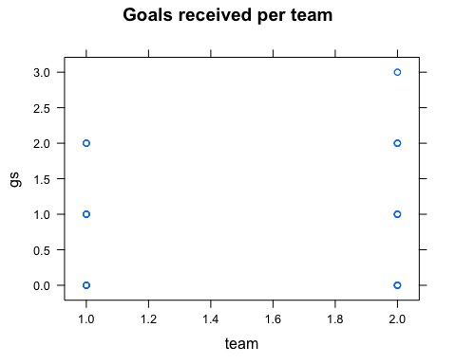

#Question 7  
qqplot(main = "Wins in relation to injuries per match", inj, win, groups = team)

## Warning in plot.window(...): "groups" is not a graphical parameter

## Warning in plot.xy(xy, type, ...): "groups" is not a graphical parameter

## Warning in axis(side = side, at = at, labels = labels, ...): "groups" is not a  
## graphical parameter  
  
## Warning in axis(side = side, at = at, labels = labels, ...): "groups" is not a  
## graphical parameter

## Warning in box(...): "groups" is not a graphical parameter

## Warning in title(...): "groups" is not a graphical parameter

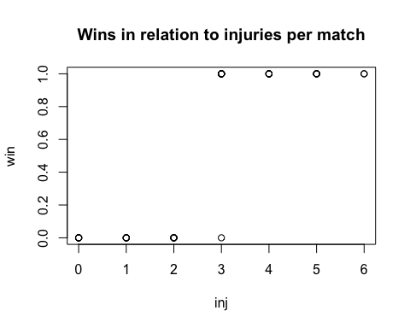

#Question 8  
cloud(gs~gd*team, data = data)

